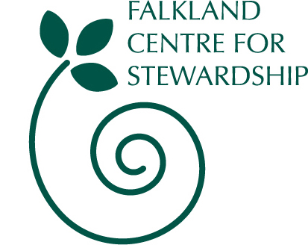

Booking form for Easter Clubs

Falkland Estate

Monday 2nd April to Friday 6th April

or Monday 9th April to Friday 13th April 2012

Dates

Which week | Please tick
Mon 2nd – Fri 6th April
Mon 9th – Fri 13th April

Participants Details

Name of child/children | Age | Cost
Total cost - £85 per child

Your Details

Your Name

Address

Email

Phone Number

Mobile (in case we need to contact you urgently)

Emergency Contact
Name:
Phone/mobile:
GP Contact
Name:
Phone:

Please let us know if there are any allergies or other issues your child has that we should be aware of (this information will be held in the strictest confidence):

Next Steps

To confirm your booking, please return this form along with a deposit for 50% of the total cost.

We will send you a receipt and invoice for the balance, to be paid in full two weeks prior to the course commencing.

If you have to cancel your place we will only be able to offer a refund if we can fill your space.

Cash or Cheque only- cheque should be made payable to Falkland Stewardship Trust. Thank you.

Return to:
Falkland Centre for Stewardship, The Stables, Falkland Estate,
Falkland, Fife, KY15 7AF
or info@centreforstewardship.org.uk.

If you have any other queries please contact us on 01337 858838 or info@centreforstewardship.org.uk

Falkland Centre for Stewardship is part of Falkland Stewardship Trust, SC022481

