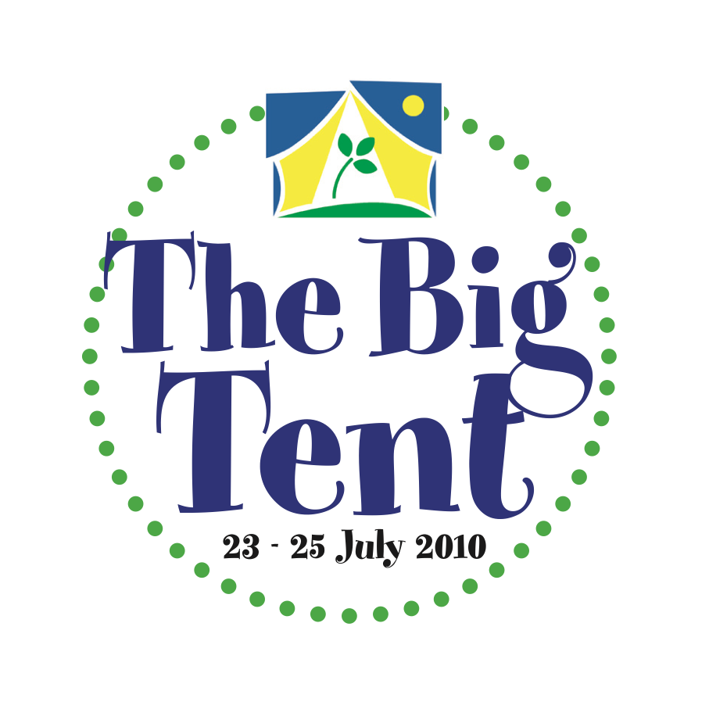

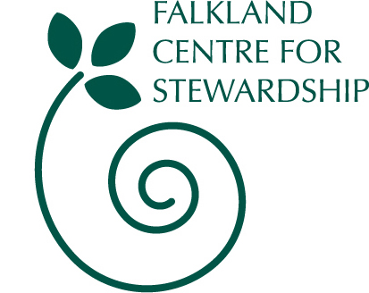

Invitation to Celebrating Crafts Seminar in Falkland, 7th & 8th May 2010
Celebrating Crafts at the Big Tent 2010 will bring the best of contemporary Scottish craft expression to a new audience at Scotland's biggest environment and arts festival. Twenty makers will be selected to show their finest work, demonstrate their skills and engage with the public in an exhibition at The Big Tent in Falkland, Fife from 23rd-25th July.
Interested artists are invited to apply for places on a professional development seminar organized by Falkland Centre for Stewardship, to:
- discover and be inspired by Falkland’s natural and built environment, including the designed landscape, forest and farm, Palace and House
- look at issues around sustainability and communication within craft
- present their work and themselves to each other to explore potential collaboration
- meet and learn from specialists in related fields e.g. the Past, Present and Future Craft Practice research, University of Dundee and the Sustainability of Craft research project, University of St Andrews.
The setting
Falkland Centre for Stewardship covers some 1500 acres of land, farm, forest and hill. As well as caring for the House of Falkland and historic landscape, we are now developing this estate as a place where people are learning how to live and work more sustainably. Our interests span from the value of re-skilling our communities to the impact of today’s decisions on climate change for future generations.
Sustainable Development: A need to re evaluate
The sustainable development agenda is a philosophy, underwritten by belief: a theory to develop a particular way of life… development that 'meets the needs of the present without compromising the ability of future generations to meet their needs.'
Craft - looking at skills and training that define it as a business model as well as the values that inform it as a choice of career and lifestyle - is seen as having common ideological ground with the sustainable development agenda. The agenda proposes a new way of looking: to develop and sustain a new society through evaluation of environmental and social impacts as well as economic.
From the Craft Scotland website www.craftscotland.org

The Programme
On Friday 7th May the seminar will run from 10:30 to 17:30, including time walking in the landscape and a visit to parts of Falkland Palace not open to the public. Contributors will include:
- Eoin Cox (Buy Design Gallery) on ‘Beige is the new brown’
- David Jones (School of Art History, St Andrews University) on ‘Bringing traditional design ideas for the contemporary world’
- Emilia Ferraro (Sustainability Institute, St Andrews University) on ‘Craft and sustainability’
- Ninian Stuart (Falkland Estate Trustee) on ‘The designed landscape and landscape in design in Falkland’.
- A member of the Past Present and Future Craft Practice (PPFCP) research team will discuss their work exploring new directions, practices and perspectives in contemporary craft – drawing from their research of the House of Falkland. (tbc)
On Saturday 8th May there will be an exclusive visit to the House of Falkland, followed by more time to explore the land individually and with local guides.
‘The House of Falkland is a rare undiscovered jewel, nestled at the foot of the Lomond Hills in Fife, Scotland… Built between 1839 and 1844 by William Burn, one of the pre-eminent Victorian country house architects, it provides a rich tableau for craft researchers to investigate and explore the indigenous techniques employed by craft artisans in the past, and to understand their aesthetic importance to the future of crafts. The House of Falkland’s magnificent interiors contain an amazing collection of unique works influenced by religion, symbolism and Byzantine architecture and it is claimed to be the best preserved of Burn’s house designs. The restoration work between 1887 and 1900 involved the construction of a chapel and superb Arts and Crafts interior redecoration. The works were done by the Scottish Architect Robert Weir Schultz and other artisans.
From the Past, Present and Future Craft Practice website http://www.futurecraft.dundee.ac.uk
Applications are invited from professional artists/craftworkers living and working in Scotland, who are:
- available to be at the Big Tent 23-25 July 2010 to exhibit, demonstrate and talk to the public about their work;
- interested in exploring the potential to create, individually or in collaboration, one or more pieces inspired by or related to the natural or built environment of Falkland, to be exhibited at the Big Tent 2010. The pieces will be made from natural or recycled materials.
The intention is that each piece will be professionally photographed in the setting which inspired its creation, the photographs to become part of the exhibition and be available for touring to other venues.
The seminar is free (including lunches, dinner on Friday and other refreshments) but places are limited so please apply early. It is hoped that participants will attend both days; a contribution towards travel expenses and the cost of overnight accommodation will be available on application to those coming too far to return home on Friday night.
Email or post your completed application form to: info@centreforstewardship.org.uk
Falkland Centre for Stewardship, The Stables, Falkland Estate, Falkland, Fife KY15 7AF
Application Form: Celebrating Crafts Seminar, Falkland Centre for Stewardship, Fife 7th & 8th May 2010
Name:
Address:
Email:
Phone (please include mobile if possible for any urgent communication):
Website:
Please describe your work:

Are you available for both 7th and 8th May? Yes / No
If not, please specify which day: 7th / 8th
Will you join us for dinner on Friday 7th 7.30-9 pm? Yes / No

Do you wish to apply for a contribution towards travel and overnight accommodation?
If so, please estimate your costs:

Please confirm that you are available for the Big Tent, 23rd-25th July:
Email or post your completed application form to:
info@centreforstewardship.org.uk
Falkland Centre for Stewardship, The Stables, Falkland Estate, Falkland Fife KY15 7AF

