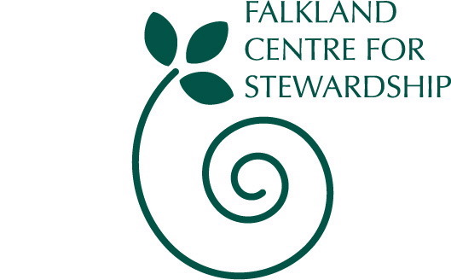
Falkland Transition Town Network

Sustainable Travel Choices Workshop

Following the success of Ben Brangwyn’s talk in December on the Transition Network another workshop has been organised focusing on one of the main issues around a sustainable community – transport. Join Stuart Knowles, senior manager of Fife Council Traffic and Transportation services and resident of Falkland as he leads us through an evening looking at sustainable transport and sustainable transport choices.
Wednesday 30th January 2008
6.30pm till 8.30pm approx

Held at the Stables Workshop on Falkland Estate*

All welcome Free event Local refreshments provided

* you may wish to bring a torch to guide you to the Workshop

Organised as part of ‘Sustainable Falkland’.

We can do so much more together than we can do alone!
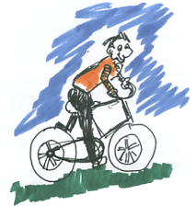
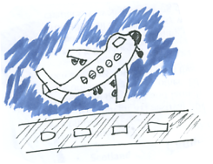

For further information contact: 01337 858838
Falkland Centre for Stewardship info@centreforstewardship.org.uk
www.centreforstewardship.org.uk

