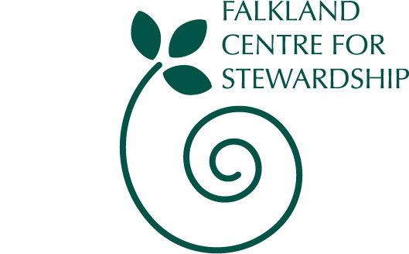

10 April 2008

Dear Friend,

I am writing to you because you have either contributed in a voluntary capacity to Falkland Centre for Stewardship in the past or at some point expressed an interest in helping out with our work on the landscape of Falkland Estate, the House of Falkland or at Big Tent.

Over the years volunteers have supported and enabled a significant amount to happen here that otherwise could not have taken place – and continue to provide generous support to the shared stewardship of this place and of the evolving Centre for Stewardship.

As a small organisation with very limited staffing, we have not always made the most of your generous offers of help. We are now seeking to rectify that by updating our volunteer database so that we can more closely match your interests to our stewardship activities, inform you of opportunities and better support.

Towards this end, I’d be most grateful if you would complete the short questionnaire enclosed and post back or drop it into the office. Alternatively, to save on postage, the questionnaire can be downloaded from our website – www.centreforstewardship.org.uk/supportus/ or you can email us at info@centreforstewardship.org.uk and we’ll email out the form.

In addition if you happen to be free on Thursday 17th April I would like to invite you to join us for a Friends’ evening at the House of Falkland. This will be a wonderful opportunity to enjoy an evening of music in the Drawing Room of the House of Falkland with the Chancefield Quintet playing Schubert C Major String Quintet. Followed by organic cheese and wine. Tickets costs £8 / £5 (Friends of Falkland’s Heritage).

Finally, if you did not get a copy of our latest Spring newsletter then remember that you can download it from our website (http://www.centreforstewardship.org.uk/news/).

I look forward to hearing from you – and thank you for your continuing interest.

With best wishes

Helen Lawrenson

Helen Lawrenson
Development Manager

Enc.

Falkland Centre for Stewardship, part of Falkland Heritage Trust, Scottish Charity SC022481,
The Stables, Falkland Estate, Falkland, Fife, KY15 7AF, tel: 01337 858838
email: info@centreforstewardship.org.uk web: www.centreforstewardship.org.uk
Volunteering Opportunities on Falkland Estate – general enquiry form

Top of Form
Name:
Address:
Telephone:
Email:

Which is your preferred method of contact | Tel <INPUT TYPE=\ Email <INPUT TYPE=\ Address <INPUT TYPE=\
Bottom of Form

Normal availability Weekdays <INPUT TYPE=\ Weekends <INPUT TYPE=\ Both <INPUT TYPE=\

Please indicate the areas that you would be interested in helping with:
Top of Form
Conservation and Surveys | Tick
I’m interested in any of the conservation & survey activities listed below | <INPUT TYPE=\
Butterfly transect methodology | <INPUT TYPE=\
Small mammal signs including water voles | <INPUT TYPE=\
Habitat surveys – squirrels | <INPUT TYPE=\
Insect identification in Coalpit and Maspie | <INPUT TYPE=\
Tree identification in Coalpit and Maspie | <INPUT TYPE=\
Flower identification in Coalpit and Maspie | <INPUT TYPE=\
Grasses,,rushes and sedges identification in Coalpit and Maspie | <INPUT TYPE=\
Woodland ecology of Fife Dens | <INPUT TYPE=\
Rhododendron clearing | <INPUT TYPE=\
Cherry laurel cutting back | <INPUT TYPE=\
Path maintenance | <INPUT TYPE=\
Burn clearing | <INPUT TYPE=\
Bottom of Form
Top of Form
Events
Big Tent Festival (26-27 July 2008) | <INPUT TYPE=\
Helping with other events eg annual stewardship lecture, children’s activities | <INPUT TYPE=\
Leading or assisting with guided walks | <INPUT TYPE=\
House of Falkland guided tours | <INPUT TYPE=\
General Office / Other
General office administration eg phone enquiries, database work, filing, sending out letters) | <INPUT TYPE=\
Photography – scanning for archiving and recording on the Estate | <INPUT TYPE=\
Any other activity – please list
Professional skills – please specify
Bottom of Form
Training and support available. Some activities (e.g. work with children) may require Disclosure. Once we have received your form back we will be back in touch. Please either email to info@centreforstewardship.org.uk or post to Falkland Centre for Stewardship, The Stables, Falkland Estate, Falkland, Fife, KY15 7AF

