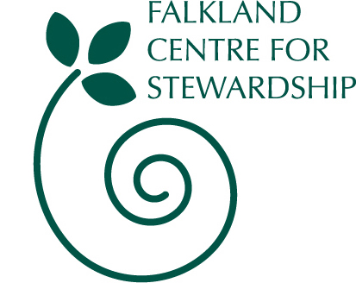

Booking form for Autumn Club, ages 7-12

Falkland Estate

Monday 10th Oct to Fri 14th Oct

10am to 3.30pm each day

Has your child attended a previous holiday club?

Please tick
No, this is the first time
Yes, been before*
* if your child has been before and the details are the same then where applicable, please write ‘as before’.

Participants Details

Name of child/children | Age | Cost
Total cost - £85 per child

Your Details

Your Name

Address

Email

Phone Number

Mobile (in case we need to contact you urgently)

Emergency Contact
Name:
Phone/mobile:
GP Contact
Name:
Phone:

Please let us know if there are any allergies or other issues your child has that we should be aware of (this information will be held in the strictest confidence):

Next Steps

To confirm your booking, please return this form along with a deposit for 50% of the total cost.

We will send you a receipt and invoice for the balance, to be paid by Friday 30th September.

If you have to cancel your place we will only be able to offer a refund if we can fill your space.

Cheques should be made payable to Falkland Centre for Stewardship.

Return to:
Falkland Centre for Stewardship, The Stables, Falkland Estate,
Falkland, Fife, KY15 7AF
or info@centreforstewardship.org.uk.

If you have any other queries please contact us on 01337 858838 or info@centreforstewardship.org.uk

Falkland Stewardship Trust, SC022481

