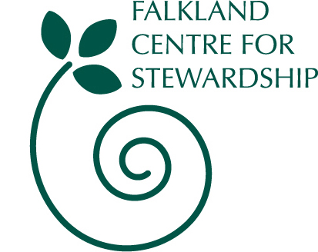

Standing Order Instructions

Under 16s £5 ** Single Membership £10 ** Family Membership £20 ** Organisations £55

Your Name

Name of your bank/building society

Address

Postcode

Account No

Sort code

Name of account holder

Amount to be transferred annually to Falkland Stewardship Trust | £
Amount in words

Date you would like to make the payment and annually thereafter on that date

Please pay to Falkland Stewardship Trust at Bank of Scotland, The Cross, Cupar, Fife, KY15 4BP, Account No. 06005348, Sort code 80-06-26, the amount specified on the date stated. Please make annual payments until further notice. This instruction replaces any previous standing orders or direct debits in favour of Falkland Heritage Trust.

GIFT AID DECLARATION
I am a UK taxpayer and wish Falkland Stewardship Trust to treat my subscription and donations as Gift Aid donations. I pay an amount of Income Tax at least equal to the tax the charity reclaims on my donations in the appropriate tax year.

Signed __________________________________________________Date___________________________

DATA PROTECTION STATEMENT
I understand and agree that the information I provide on this form will be held securely in order to process my application to become a Friend and for mailing purposes. I further understand that this information will not be given to any further organisation. Under the terms of the Data Protection Act (1998) I can ask for details of the information held about me by Falkland Stewardship Trust.

Signed __________________________________________________Date______________________________

PLEASE FILL IN AND RETURN TO : Falkland Centre for Stewardship, The Stables, Falkland Estate, Falkland, Fife, KY15 7AF
Falkland Stewardship Trust is a registered Scottish Charity, SC022481

